

The course involves a mixture of presenter input, discussion and tasks.

The focus will be on reducing the chances of accidents involving staff and students to a minimum;

During the course the following items will be covered:-

* Health and safety regulations and how they affect science education.
* The law and health and safety. What the law requires employers, teachers, technician and heads of department to do.
* Exploration of basic principles relating to health and safety.
* Requirements for science labs in respect of health and safety.
* Organising and managing risk assessment in science education, including the customisation of model risk assessments.
* How to audit a science department
* Discussion around common areas of concerns found when auditing science departments

There will also be ample opportunities for participants to raise questions about their own concerns.

Participants who attend the whole course will receive a CLEAPSS Certificate of Attendance.

Date: Tuesday, 5 November 2024

Times: Start 9am. Finish 4pm (approx.)

Location: CLEAPSS, Chesham, Buckinghamshire, HP5

Cost: £165 for CLEAPSS Members

**Tel: 01895 251496**

**Email: courses@cleapss.org.uk**

**Auditing Science Departments and**

**Health & Safety Management**

**for Safety Officers**

This course is designed for Safety Officers. The main emphasis is on management issues, risk assessment and the auditing and monitoring of H&S practice.

**www.cleapss.org.uk**



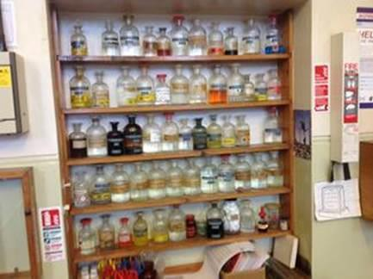

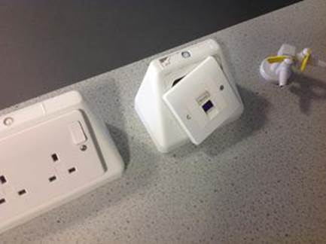

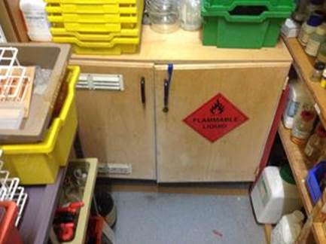

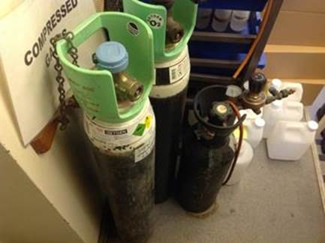

**Tel: 01895 251496**

**Email: science@cleapss.org.uk**

**www.cleapss.org.uk**